Peer Reviewed: Charmaine Lum

December 7, 2018

**Technical Documentation**

**Cooling System Vents/Radiator Mount:**

The purpose of this tutorial is to create a 3-D printed mount made of any type of plastic material. Usually we strive for a translucent green 3-D printer filament because that kind of material is meant to sustain more temperature sensitive components of the WAM-V (which was what we used for the high current box). But due to limited resources of the translucent green 3-D printer filament, we opted to use a white one for our second radiator mount for the low current box. The material serves the same function but not as temperature sensitive as the green colored.

**Materials Required:**

* Translucent Green 3-D Printer Filament (or any available color you can find)
* 3-D Printer big enough to print a 16 in. mount in length
* 5/16 Fasteners, 5/16 Washers (approximately 50 EA), 5/16 Plated Nuts (7 EA)
  + Two 4 in. 5/16 fasteners and three 6 in. 5/16 fasteners
* Phillips screws (These should come with the radiator when you purchase the box)
* Steel Piping for covering of
* 13mm Wrench
* Drill with drill bit “Q” for 5/16 fasteners and ½ space needle to cut out a hole for cooling tubes
* Coils to connect the cooling tubes to the radiator

**Specifications:**

Schematics for the radiator mount:

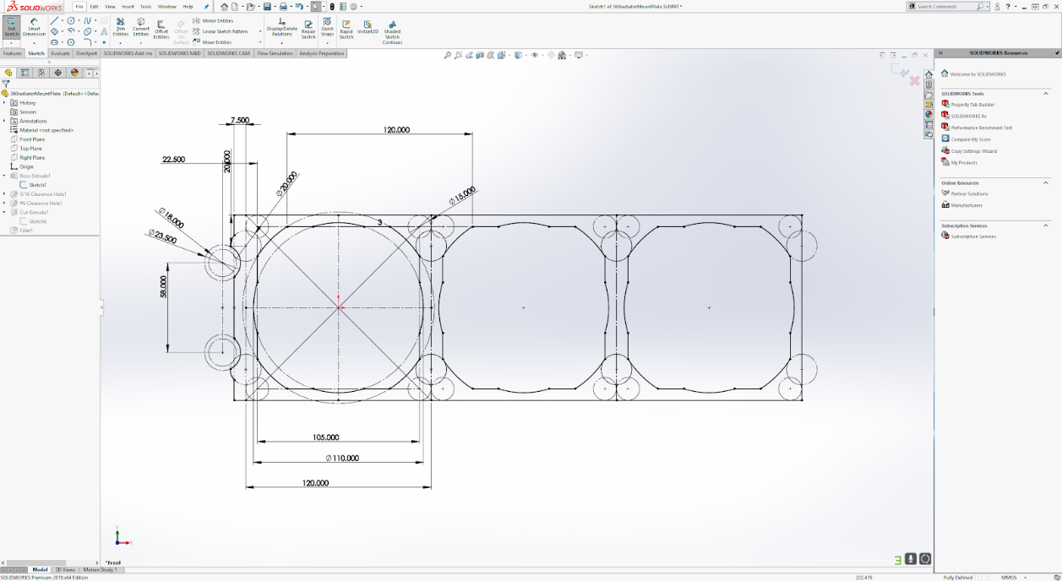

**Installation Process:**

1. Collect all your materials stated in the requirements above
2. Start off by marking your dimensions on your designated box
   1. In our case, we used an empty plastic box as the low current box to attach the radiator mount
   2. The placement of the radiator on the low current box should be an exact mirror (opposite sides of each other) to the high current box
   3. The reasoning behind this is because there is a triangular beam on the WAM-V in the middle of the two boxes
3. The dimensions for where the holes should be cut are:
   1. On the left side of whichever short end face, you are using of the box:
      1. The 1st mark should be 1 and 14/16 inches coming from the top
      2. From Mark 1, measure Mark 2 up to 2.5 inches
      3. From Mark 2, measure Mark 3 up to 3 and ¾ inches
      4. Then from there, measure Mark 4 up to 4 and 14/16 inches
   2. In the center of the box:
      1. Coming from the left side, the 5th mark should be ¾ inches horizontally and 1.5 inches vertically
         1. The 7th mark should line up with the dimensions above and land on the angled part of the box
      2. The 6th mark is marked: 2.85 inches vertically and 2.25 inches horizontally
4. Use Drill bit “Q” for Marks 1,4,5,6,7 and drill a hole straight through
5. Use space needle “1/2” for Marks 2 & 3 and drill a hole straight through
6. To assemble the radiator to the mount:
   1. Place the 4 in. fasteners should be at holes 1 & 4 and the 6 in. fasteners should be at holes 5,6,7
   2. Then use Philips screws and screw them at the holes of the radiator (should use all 10)
7. Create 3 aluminum shafts for each of the three 6 in. fasteners. Each length should be approximately 4 inches long
   1. The shaft that will be covering the fastener in hole 7 should be sanded to the angle of degree of the box (roughly 45 degrees)
   2. Place them onto the three 6 in. fasteners before officially attaching the entire mount onto the low current box
8. Attach the entire mount to the designated holes
   1. Apply a plated nut on both sides of each of the 4 in. fasteners and a washer on the inside area of the box
   2. For the remaining three 6 in fasteners, apply roughly 8-10 washers on each fastener and tighten it with a plated nut
   3. It should look like this:

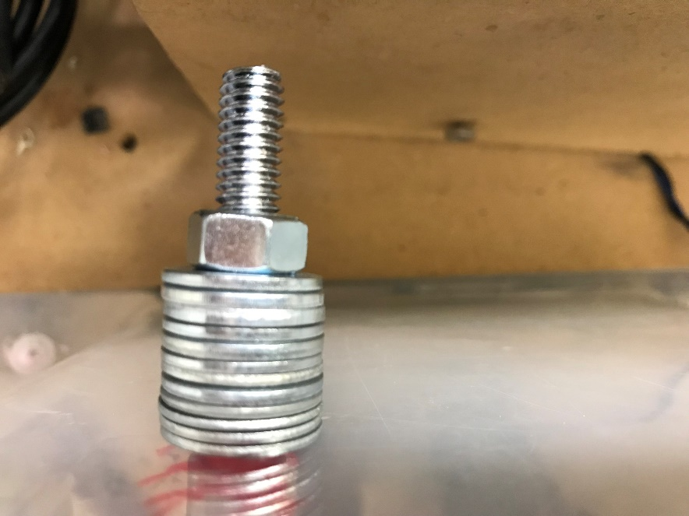

The product should look like this:

